Activity: Sitemap Design

Members: Block:12-ITEM-01
Maria Ericka Prado
Kimberly Ann Marin
Christian Marzal

SITEMAP:
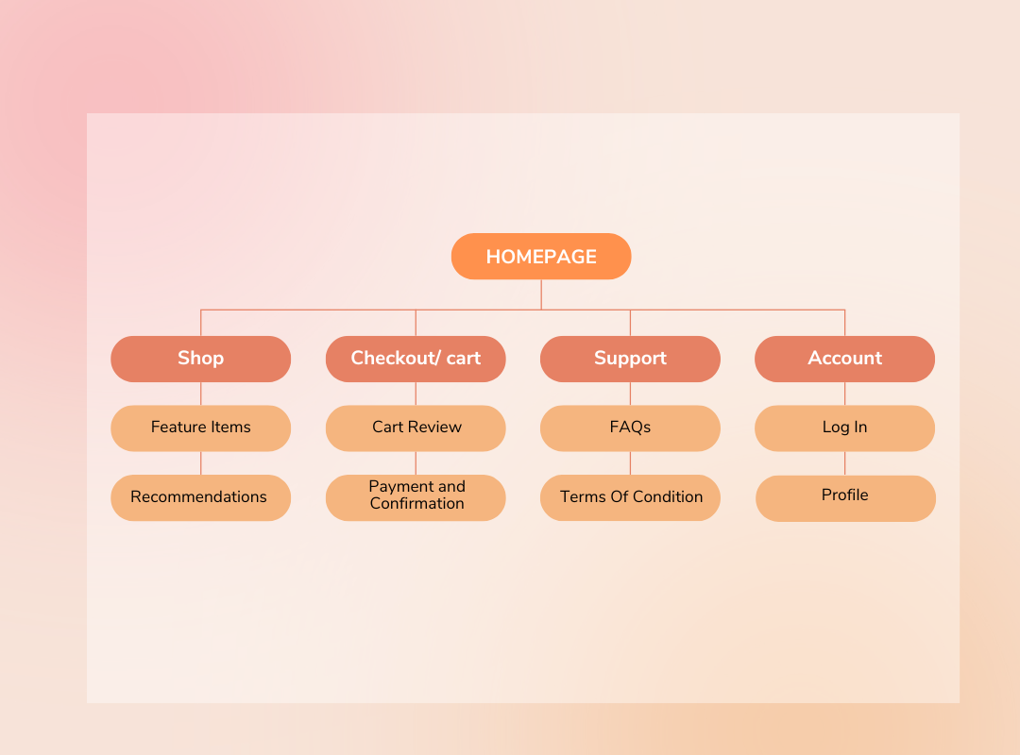

EXPLANATION:
We organized our sitemap in a simple pattern for easier use and understanding when users utilize our website for their personal agenda, such as to shop, see reviews, or connect with suppliers, they‘ll be able to identify where it is. Each category contains related subpages, that easily access the features and information they need; in this way, we deliver a clear, efficient browsing experience for users.

